**WEEK – 7**

**REACT**

**9. ReactjS-HOL:**

By following the steps given in handson, the following output has been obtained.

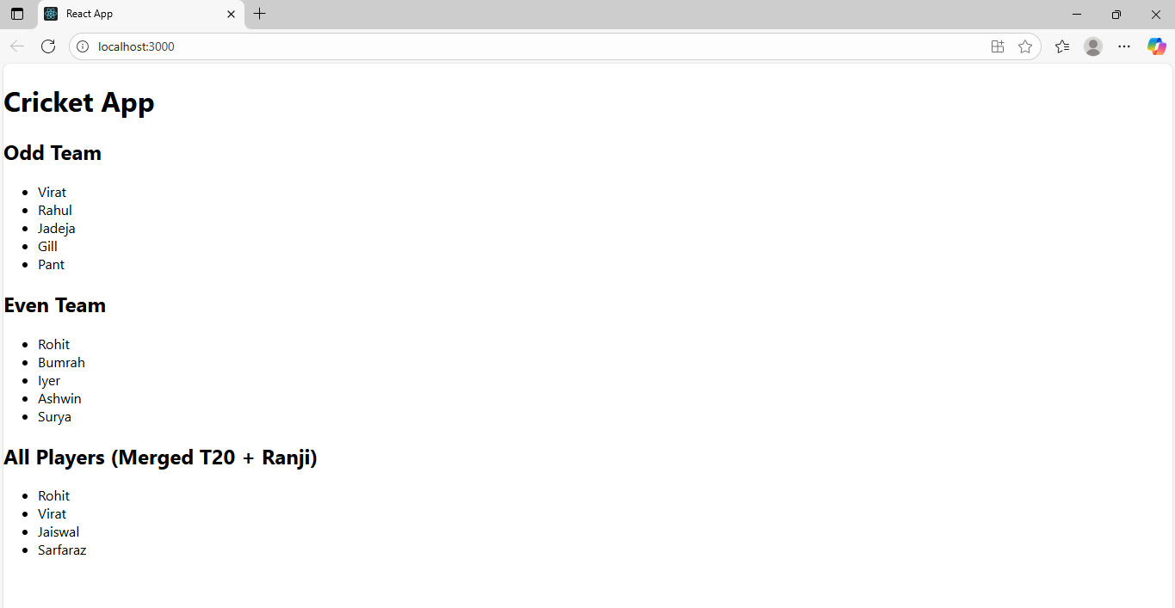

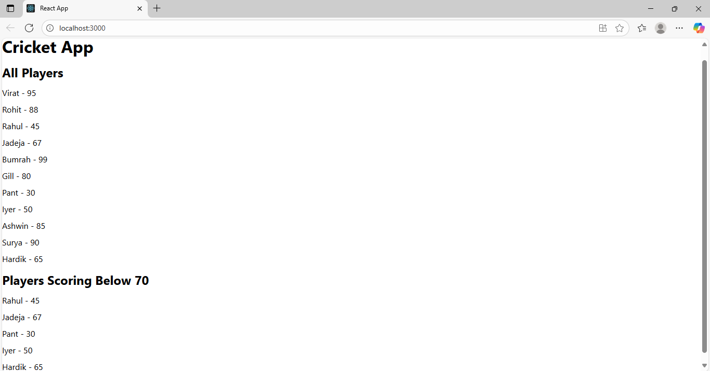

**10. ReachJS –HOL:**

The result for this handson is obtained as below

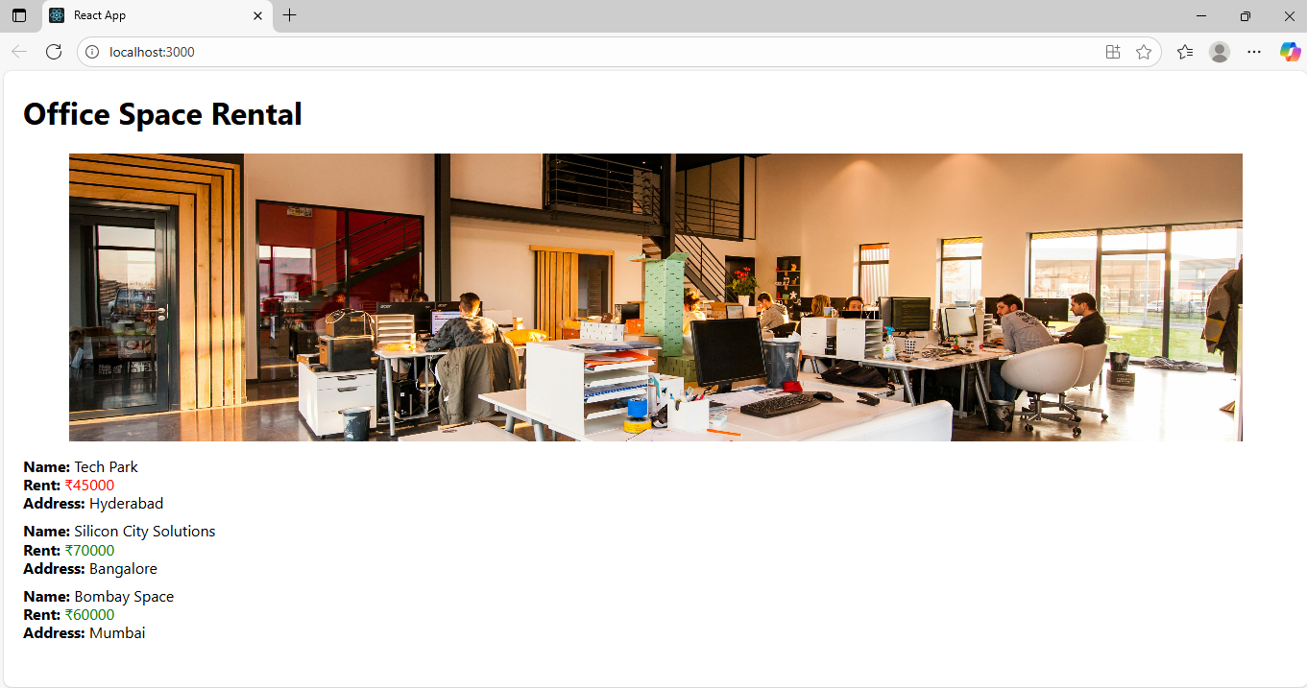

**11. ReactJS-HOL:**

Currency Conversion:

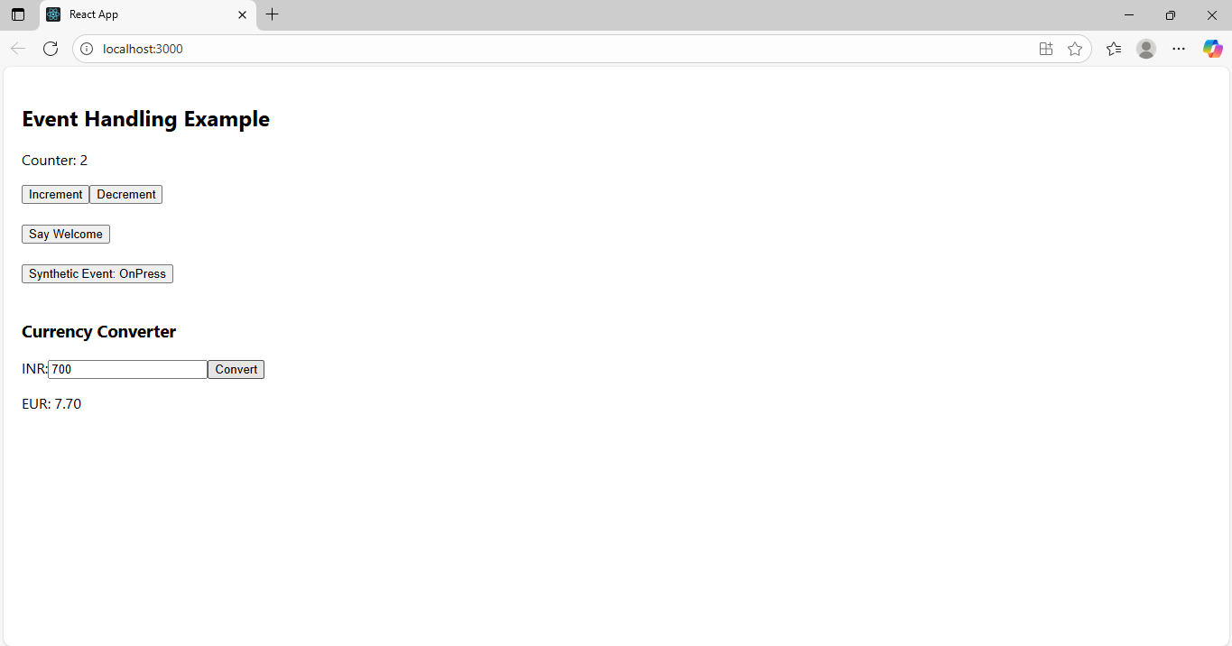

Say Welcome:

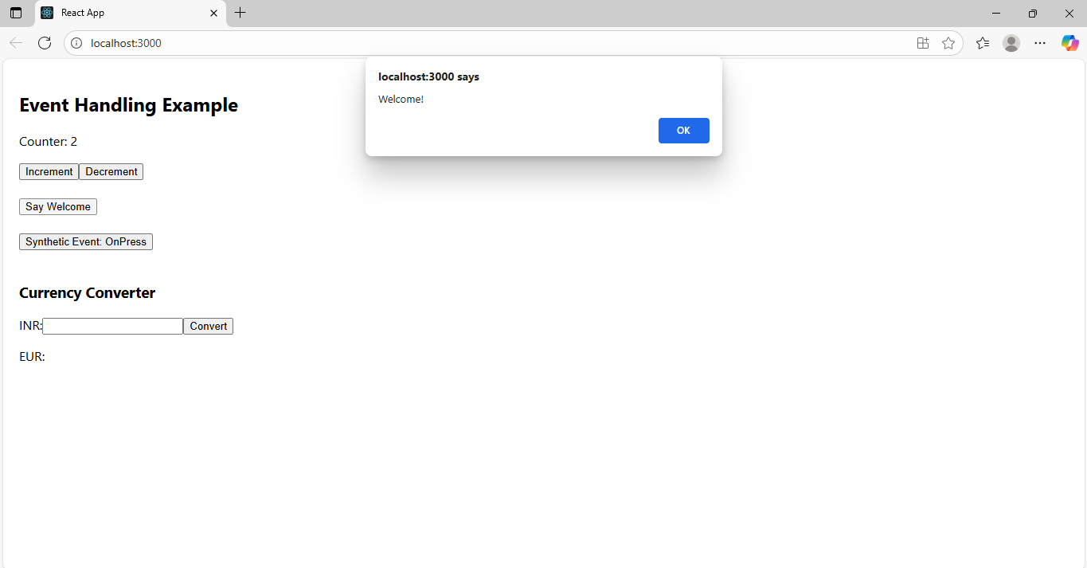

Synthetic Event:

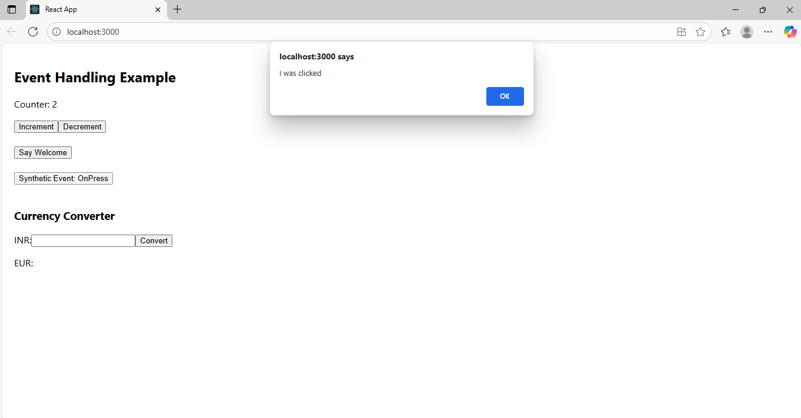

Increment:

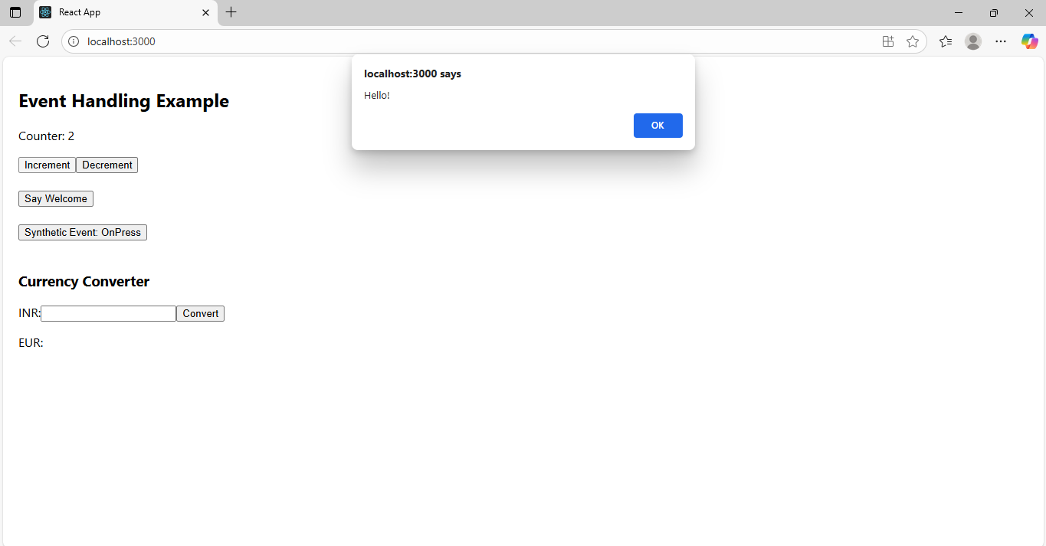

**12. ReactJS-HOL:**

Existing User:

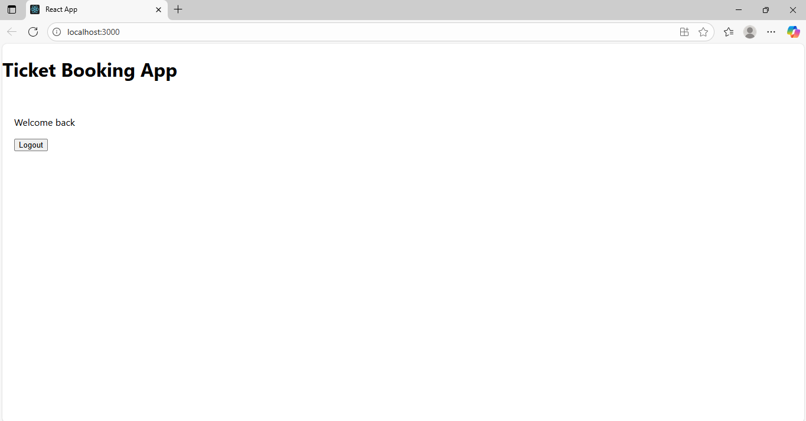

New User:

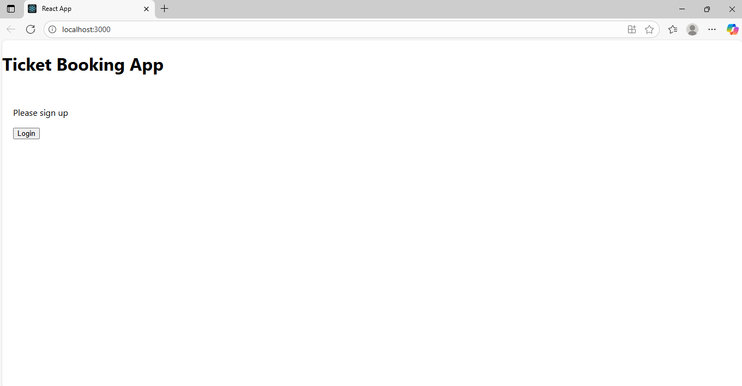

**13. ReactJS-HOL:**

